### **MapReduce and PageRank**

**Question 1**:

Suppose our input data to a map-reduce operation consists of integer values (the keys are not important). The map function takes an integer *i* and produces the list of pairs (*p*,*i*) such that *p* is a prime divisor of *i*. For example, map(12) = [(2,12),(3,12)].

The reduce function is addition. That is, reduce(*p*,[*i*1,*i*2,...,*ik*]) is (*p*,*i*1+*i*2+...+*ik*).

Compute the output, if the input is the set of integers 15, 21, 24, 30, 49.

Ans.

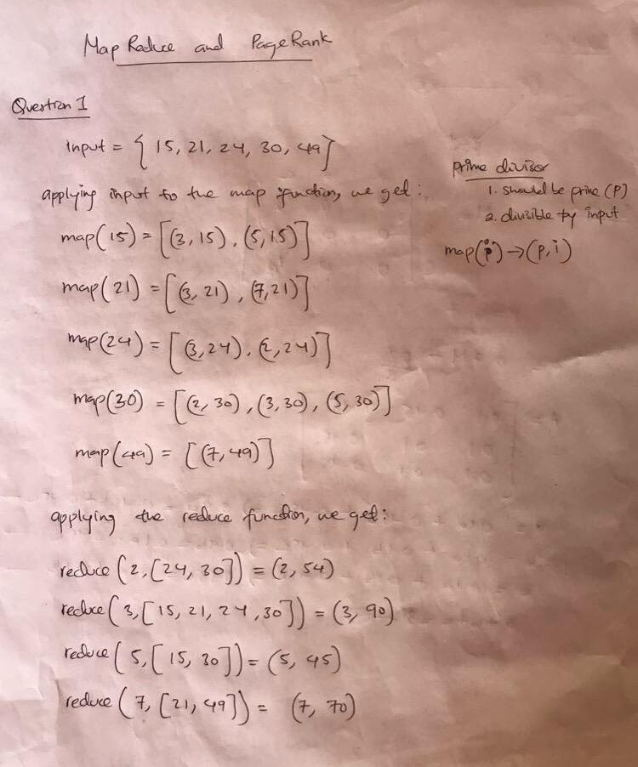

**Question 2**:

Consider three Web pages with the following links:

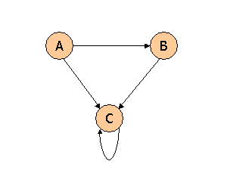

Suppose we compute PageRank with a β of 0.7, and we introduce the additional constraint that the sum of the PageRanks of the three pages must be 3, to handle the problem that otherwise any multiple of a solution will also be a solution. Compute the PageRanks *a*, *b*, and *c* of the three pages A, B, and C, respectively.

Ans.

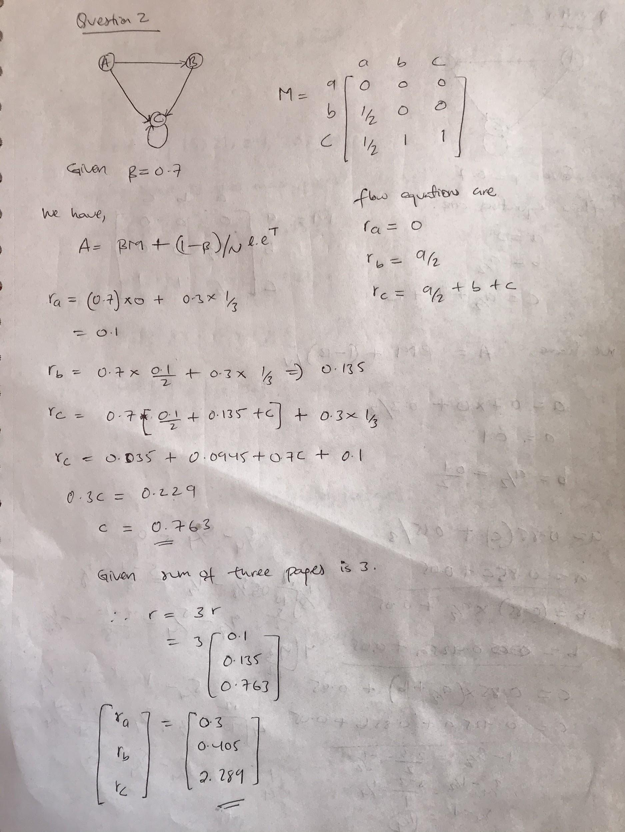

**Question 3**:

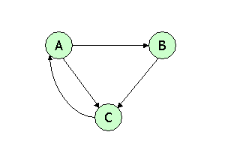

Suppose we compute PageRank with β=0.85. Write the equations for the PageRanks *a*, *b*, and *c* of the three pages A, B, and C, respectively.

Ans.



**Question 4**:



Assuming no "taxation," compute the PageRanks *a*, *b*, and *c* of the three pages A, B, and C, using iteration, starting with the "0th" iteration where all three pages have rank *a = b = c* = 1. Compute as far as the 5th iteration, and also determine what the PageRanks are in the limit.

Ans.



Suppose threshold t = 0.5

Then, r5 - r4 < 0.5

Therefore, r5 is within the limit.